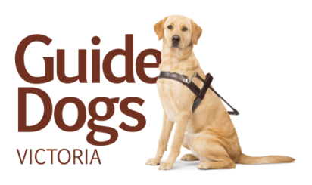
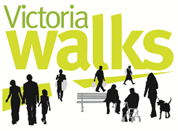

Media release

June 19, 2014

New study identifies problems on our roads for vision impaired walkers

An audit of intersections and footpaths at five Victorian locations has revealed that motorists’ failing to give way at traffic lights is the biggest problem for pedestrians who are blind or have low vision.

As part of the audit, 113 pedestrians with low vision were surveyed at Kew, Kooyong, Kensington, Geelong and Belmont.

The study found that 81 per cent of those surveyed said motorists’ failing to stop is their biggest concern at traffic lights. The audit also revealed other problems such as poor intersection design, dangerous rail crossings and sub-standard shared paths, even in areas where people with vision impairment frequently walk.
The tool used in the audit was developed by Victoria Walks – the State’s leading organisation in walking – together with orientation and mobility specialists from Vision Australia and Guide Dogs Victoria, and road safety and engineering experts.

The audit tool, funded by Victorian Community Road Safety Partnership Program run by VicRoads, is a comprehensive checklist that can be completed online or in a downloadable format.

“VicRoads has to be commended for funding this work to look at the problems faced by pedestrians who have vision impairment,” said Dr Rossiter, Executive Officer at Victoria Walks.
The tool was also developed to build a better understanding of why 1 in 12 pedestrians with vision impairment have been hit by a vehicle or cyclist in the past five years.
Ron Hooton, Vision Australia Chief Executive Office, and Karen Hayes, CEO Guide Dogs Victoria said the findings are a reminder to the community to be mindful of those who rely on the good sense of drivers.

“Just like a mother with a pram, people who are blind or have low vision rely on sensible driving by motorists and need to be able to trust the safety standard of footpaths and intersections when they’re out and about.”

The organisations also sought advice from VicRoads and local councils when developing the tool. It, and the findings, have now been presented to road safety authorities and local councils to use so they can continue to capture relevant road safety and engineering issues that relate to pedestrians with vision impairment.

To find out more about the audit tool, go to www.visionaustralia.org/roadsafetyaudit

- ENDS -

Further comment: Dr Ben Rossiter, Executive Officer, Victoria Walks 9662 3975/ 0425 805 578 brossiter@victoriawalks.org.au

Rebecca McLean, Communications Advisor, Vision Australia 0428 496 105 Rebecca.McLean@visionaustralia.org

Michelle Kelso, Marketing Manager, Guide Dogs Victoria, 0412 189 550 Michelle.K@guidedogsvictoria.com.au

