Audit conclusions

Priority issues
Rank the most important issues you have identified, with 1 being the worst. You may identify less than five.

Overall comments
Provide any general concluding comments

Audit map
Insert map of audit with location of each checklist indicated – example below
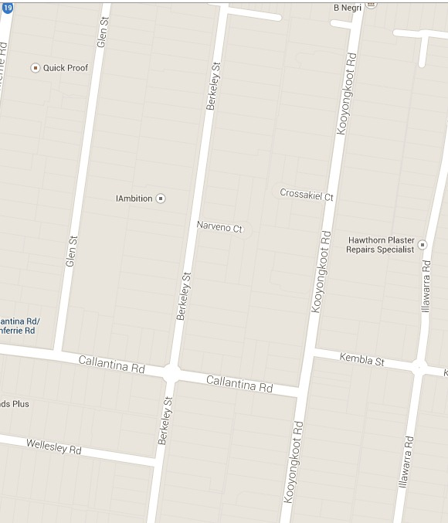
10
9
8
7
6
5
4
3
2
1

