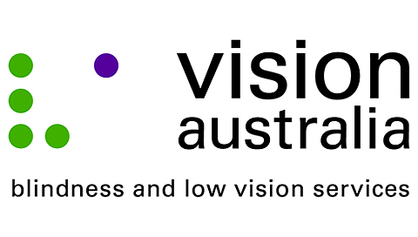

Dear Minister Turnbull,

I implore you to take action to ensure that audio description is finally made available on Australian television.

Audio description is the auditory narration of the visual elements of a television program, such as scenes, settings, actions and costumes, through a separate soundtrack between gaps in dialogue.

Without audio description, people who are blind or have low vision are unable to fully engage with their favourite television programs.

They also can’t appreciate the experience of watching or discussing television with others, which is a regular pastime that most Australians take for granted.

Limiting audio description to catch-up services online also don’t allow for this and are particularly useless for sport, news and current affairs.

Making audio description available on all Australian television stations by establishing mandated service levels would allow people who are blind or have low vision to experience television in a more inclusive way.

Australia has fallen behind the rest of the world. The majority of comparable countries around the world have audio description on television, including both the United Kingdom and Canada, who have compulsory standards for television broadcasters in the provision of audio described content.

My personal interest in audio description is

This issue is begging for your leadership.

I look forward to receiving your response.

Yours Sincerely,

