Glaucoma

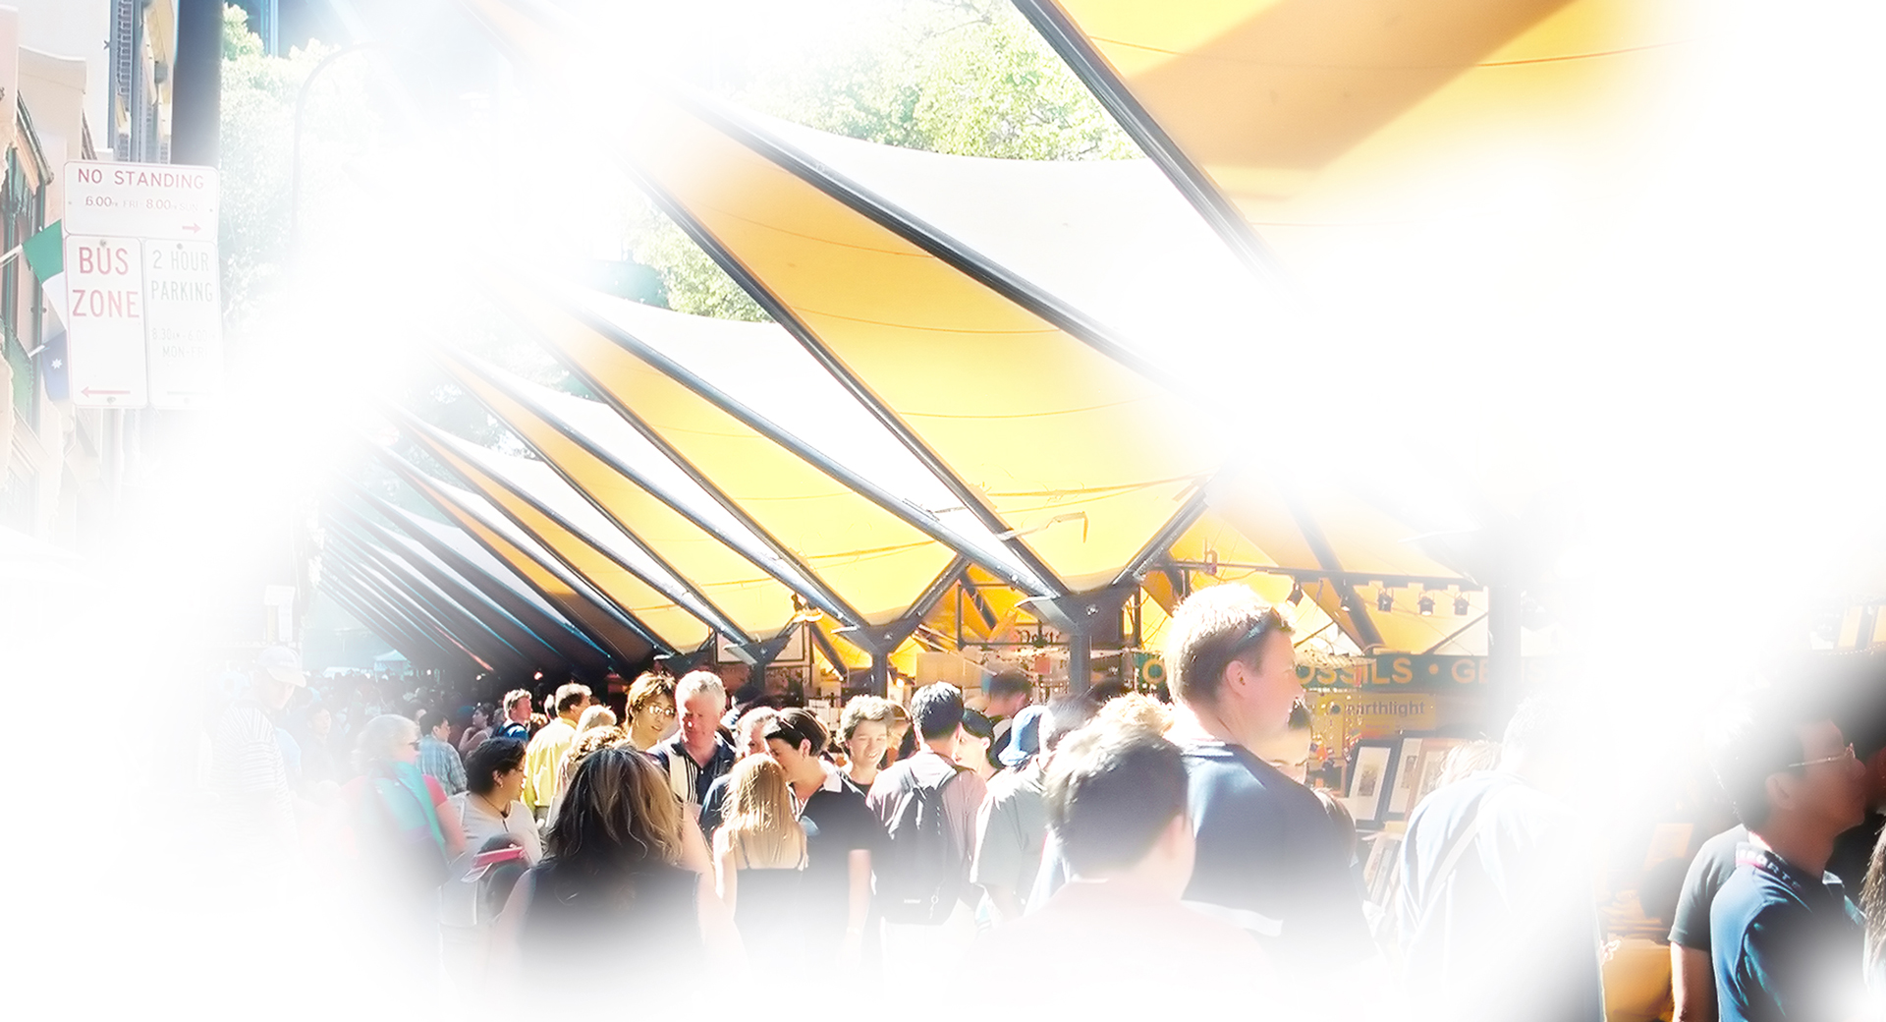
Glaucoma simulation
What is glaucoma?
Glaucoma is a group of eye diseases in which there is progressive damage to the optic nerve which carries vision information from the eye to the brain.

Glaucoma is often associated with high intraocular pressure (fluid pressure inside the eye) resulting from a problem with the drainage system of the eye.

Early detection and treatment are crucial to minimise vision loss.

What are the common symptoms?
The most common form of glaucoma starts with the loss of side vision (peripheral vision). There is no associated pain or discomfort. The lack of symptoms makes early detection difficult.

As the disease progresses, symptoms may include:
- Painless blurred vision
- Difficulty adjusting to low light
- Poor vision in dim light which may lead to falls or a loss of confidence
- If untreated the continued loss of peripheral vision can lead to tunnel vision or blindness.

Who is at risk?
Those most at risk include people who:
- Have a family history of glaucoma
- Are aged 40 years and over
- Are short sighted
- Have diabetes
- Have had a serious injury to the eye
- Used steroids regularly over a long period of time
- Have hypertension.

Can glaucoma be treated?
Glaucoma can be treated with eye drops or other medication, laser treatment or surgery. Treatment needs to be ongoing and cannot restore vision which has already been lost.

Early detection and treatment of this condition can prevent or delay vision loss. Regular checks with an eye care professional are important for anyone over 40 but especially those in high-risk categories.

How can Vision Australia help?
Vision Australia provides support and services to people of all ages and stages of life who are blind or have vision loss.

We work with people to achieve what’s important to them such as studying, finding or retaining employment, leading an active social life or continuing to do the things they love.

With the support of our professional teams, people who are blind or have low vision can develop their skills and make use of technology and equipment that will enable them to live independently.

Contact Vision Australia
Call 1300 84 74 66
Email info@visionaustralia.org
Website visionaustralia.org
Locations VIC | ACT | NSW | QLD | WA

